|  |  |  |
| --- | --- | --- |
| **Lyng Primary School P.E Knowledge Organiser** | | |
| **Topic: GYMNASTICS** | Year 4 | Spring 1 |





**Enquiry Questions**

* How can we link jumps and leaps together?
* Can you perform a point balance, on your own, with a partner or in a group?
* How do we perform a forward’s roll?
* Can you perform a sequence using a roll, leap, balance and jump?
* Can we mirror a partner on a bench opposite?
* How can we mount and dismount a vault safely?

|  |  |
| --- | --- |
| **Key words** | |
| **Spelling** | **Definition** |
| Egg roll | Knees tucked up to chest, rotate your body and roll across the mat. |
| Counter Balance | A counter balance is where a pair/group share each other’s weight when balancing. |
| Star jump | Being able to start with a straight body jump and whilst in the air, perform a star and when landing return to start point. |
| Landing | When returning to the ground safely, landing on your feet. |
| Dismount | When you are coming off equipment working at height. |
| Sequence | Being able to link everything learnt and perform a sequence to the group. |

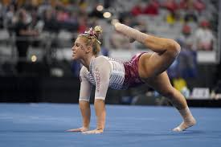

***“Hard days are the best because that’s when champions are made.”***

**– Mav Levy**

|  |  |  |
| --- | --- | --- |
| **Lyng Primary School P.E Knowledge Organiser** | | |
| **Topic: GYMNASTICS** | Year 4 | Spring 1 |

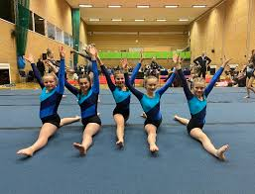

Learning Outcomes

* To be able perform jumps and leaps together.
* To be to perform individual, partner and group point balances.
* To be able to perform a variety of rolls.
* To be able to complete a sequences using a variety of movements, balances, rolls and jumps.
* To be able to mirror a partner’s sequence on a bench opposite.
* To be able to perform jumps when using a vault.